**5th Grade Summer Activities**

**The summer assignment is due the first day of school and will be recorded as a grade.**

**READING**

This summer all rising 5th graders must read ***Hatchet***by Gary Paulsen.

**Activity:**

Students are required to read *Hatchet* by Gary Paulsen.  Once the novel is complete, students must create a trading card based on the main character from the story, using the Trading Card Creator tool found at:

http://www.readwritethink.org/parent-afterschool-resources/activities-projects/summer-trading-cards-30864.html?main-tab=2#tabs.

Feel free to be creative and add additional images or information to your card.

**Rubric**

Trading Card Rubric – You must check the site above to locate the components.

**Novel Character Information**

__2_ Trading card has name and picture of a main character from the novel.

__1_ Trading card is missing name or picture of a main character from the novel.

**Trading Card Components**

__5_ Card is formatted correctly with 5 components.

__4_ Card is formatted with 4 components.

__3_ Card is formatted with 3 components.

__2_ Card is formatted with 2 components.

__1_ Card is formatted with 1 component.

**Grammar & spelling (conventions)**

__3_ Writer makes no errors in grammar or spelling.

__2_ Writer makes 1-3 errors in grammar and/or spelling.

__1_ Writer makes more than 4 errors in grammar and/or spelling.

**10/10=100**

**MATH**

**\*\*\*Mastery of multiplication facts through 12 is a grade level expectation. \*\*\***

Students should bring in a two minute student made timed practice test

for **each** of the facts (3, 4, 6, 7, 8, 9, 10, 11, and 12). Tests should be signed and

graded by the parents to verify that students have mastered these facts.

Some helpful websites to help prepare are as follows:

www.multiplication.com

www.firstinmath.com

**Students need to know the place value system from** **millions to the thousandths.**

**Study the chart below and be prepared for a place value test at the beginning of the year.**

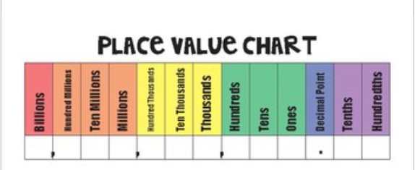

**5th Grade Supply List**

* #2 Pencils (at least 100 pencils)
* cap erasers
* 1 pack blue/ black pens
* Expo Markers
* supply of loose leaf paper for the year
* two packs of lined index cards
* 10  composition notebooks  (2 per class – 1 science log book 1 STEM notebook)
* 1 -  1 inch three ring binders
* dividers
* scissors
* 12 or 24 colored pencils
* 6- three prong vinyl folder with pockets
* graph paper (math)

**\*\*\*Items for Class Donation:**

* tissues
* hand sanitizer
* plastic sleeves
* pack of copy paper or cardstock (any color)
* construction paper
* markers
* dry erase markers
* crayons
* glue